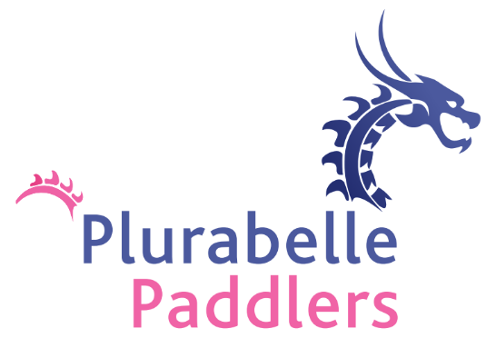
Policy Number 10:

Social Media & Website

Introduction
Plurabelle Paddlers is committed to fostering a positive, inclusive, and respectful online presence. This social media and Website Policy outlines the guidelines for how our team members, supporters, and community interact online, both on official team platforms (social media accounts and website) and in personal online spaces.
This policy applies to all members, volunteers, and affiliated individuals representing Plurabelle Paddlers on any online platform, including but not limited to Facebook, Twitter, Instagram, TikTok, LinkedIn, YouTube, and our official website.

1. Social Media Conduct
When engaging on social media, whether through personal accounts or official Plurabelle Paddlers channels, members are expected to:
- Be Respectful and Inclusive: Always treat others with respect, kindness, and consideration. Discrimination, harassment, hate speech, or any form of inappropriate behavior will not be tolerated.
- Promote Positivity: Plurabelle Paddlers aims to inspire and empower through sport. Use social media to promote team spirit, teamwork, inclusivity, and community engagement.
- Respect Privacy: Do not share any personal information about teammates, volunteers, or other stakeholders without consent. This includes photographs, videos, or any other identifying details.
- Be Authentic: Represent Plurabelle Paddlers in a truthful and transparent manner. Do not post misleading or false information about the team, events, or individuals.
- Maintain Professionalism: Even when expressing personal opinions, remember that you are associated with Plurabelle Paddlers. Keep personal and professional views distinct, especially on sensitive topics.
- Follow Legal Guidelines: Abide by all relevant laws, including copyright laws (e.g., do not share media or content that you do not own or have explicit permission to use).

2. Official Social Media Channels
Official Plurabelle Paddlers social media channels are the primary means of sharing team news, events, achievements, and updates. These include:
- Facebook: https://www.facebook.com/p/Plurabelle-Paddlers-61558865446447/
- Instagram: https://www.instagram.com/p/Crv8hzcIa-e/
Official Social Media Management:
- Social Media Coordinators: Plurabelle Paddlers has two appointed Social Media Coordinators and a Board representative responsible for managing and overseeing all official team posts. These coordinators will jointly consult on any content being posted to ensure alignment with the team’s values, voice, and messaging.
- Content Approval Process: All posts, images, videos, and updates intended for official team social media channels will be reviewed and approved by both Social Media Coordinators before publication. This ensures consistent and coordinated messaging across all platforms.
If you would like to share content on these platforms, please follow these guidelines:
- Approval for Posts: Content must be approved by the team’s Social Media Coordinators before being shared on any official account.
- Tagging: Members are encouraged to tag the team’s official social media accounts in their personal posts when appropriate.

3. Website Content
The official Plurabelle Paddlers website (www.plurabellepaddlers.com) serves as a primary platform for team updates, resources, event information, and contact details. All website content should reflect the following principles:
- Accuracy and Transparency: Ensure that all content is current, fact-checked, and reflects the true nature of the team and its activities.
- Respect Intellectual Property: Only use images, text, and videos that have proper attribution or permission. Where possible, credit photographers and content creators.
- No Offensive Content: Content posted to the website should align with our values of inclusion, respect, and positivity. Avoid any discriminatory, offensive, or inappropriate language or imagery.
- Encourage Engagement: The website should encourage communication with the team. Positive engagement with the community is encouraged.
Website Content Management:
- All content intended for the website (including blog posts, event information, team updates, etc.) must first be sent to the appointed Social Media Coordinators/Board representative for review. This ensures consistency in messaging across the website and official social media channels.

4. Personal Social Media Use
When representing yourself online as a member of Plurabelle Paddlers, please keep the following in mind:
- Be mindful of the public nature of social media: Even if posting from personal accounts, remember that the broader community, including other paddlers, sponsors, and potential supporters, may see your posts.
- Content that can be harmful to the team’s image: Criticism of the team or other members should be handled privately. Publicly airing grievances or negative opinions about the team or fellow members on social media is discouraged.
- Remember the spirit of Dragon Boating: As a sport that thrives on teamwork and unity, it’s important that we uplift and support one another both on and off the water.

5. Safeguarding and Child Protection
Plurabelle Paddlers takes the safeguarding of minors seriously. When interacting online, ensure:
- No private messaging with minors: Team members should avoid engaging in one-on-one, private social media conversations with minors unless they are parents or guardians.
- Parental Consent for Photos/Videos: Ensure that any media featuring minors has explicit consent from their parents or guardians before being posted online.

6. Crisis Management
In the event of a crisis or controversial issue affecting the team, social media and website content will be managed carefully to:
- Maintain Calm: Avoid escalating a crisis. Any official statements or responses should be issued via the team’s social media channels or website.
- Team Support: If there is any issue or controversy, please refer the matter to the team’s board who will provide guidance and direction for handling the situation.

7. Monitoring and Enforcement
Plurabelle Paddlers reserves the right to monitor all team-related social media accounts and website content to ensure compliance with this policy. Any behavior deemed inappropriate, harmful to the team’s reputation, or in violation of the policy may result in disciplinary action, including potential removal from the team or the suspension of social media privileges.
Acknowledgement
By participating in social media and contributing to the website, you acknowledge that you have read, understood, and agree to follow this policy.

Approved by Board: 23/02/2026 Revision Date: February 2029

