Safety Statement 2026 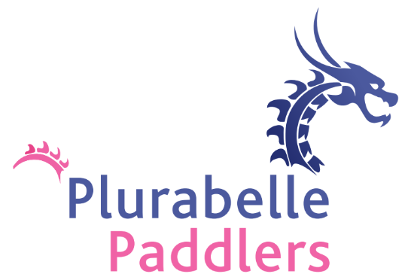

The Plurabelle Paddlers is committed to encouraging our members to take part in all activities safely, bearing in mind that the health, wellbeing, and safety of each individual member is a matter of personal responsibility.

It is the policy of Plurabelle Paddlers to promote standards of Health and Safety, to continually improve our safety performance and to ensure that the best practicable methods of compliance are achieved. This will be achieved by the following insofar as is reasonably practicable:

- The provision of safe buildings, dragon boats, pontoons, and equipment, including safe access and egress.
- The provision of appropriate information, instruction, training, and supervision.
- Determining and implementing appropriate preventative and protective measures.
- Having due regard to the principles of prevention.
- The promotion of emergency plans and procedures.
- Reporting accidents and incidents.
- Obtaining, when necessary, the services of a competent person to advise on Health and Safety.

Plurabelle Paddlers are also committed to managing and conducting club activities in such a way as to prevent (insofar as is reasonably possible) any improper conduct or behaviour, including bullying or harassment, which is likely to put the health, safety, or welfare of members at risk.

Responsibility for health and safety within the club lies with its’ members. The Board of the Club shall promote safety of members while participating in activities. Members are encouraged to put forward suggestions for improvements in this respect. The Safety Statement will be reviewed considering experience and future developments within Plurabelle Paddlers.

The Board of the Plurabelle Paddlers will ensure:
- Adequate resources are made available so that the safety policy can be carried out efficiently.
- The members of Plurabelle Paddlers are made aware of their responsibilities and are accountable in relation to Health and Safety protocols within the club.
- The appointment of a Safety Officer
- Safe systems and practises are incorporated into activities carried out by the club.
- Activities are monitored and that any potentially unsafe practises are reported and eradicated where possible
- Any specialist or Health and Safety training, if required, is discussed, and authorised by the Board, and promoted
- All functions in the Clubhouse have the Boards prior authorisation.
- Sub committees for the purpose of the day to day running of the club are formed as an essential part of being a member of The Plurabelle Paddlers.

The Secretary will ensure that:
- Any discussion, reports or suggestions relating to the Safety Statement which are raised at Board Meetings are recorded and actioned.
- All Accident Reports, Health and Safety Audits etc; are retained as club records and any correspondence relating to Health and Safety is brought to the attention of the Board and any subsequent actions are recorded.

The Safety Officer will ensure that:
- The Safety Statement is updated as required and is available to Club Members.
- The Safety Guidelines are updated as required and available to Club Members.
- All incidences in relation to health and safety are recorded and reported to the Board.

Club Members will ensure that:
- They are aware of the provisions of the Safety Statement and that they always operate within those provisions.
- They take responsibility for their own safety & engage in paddling activities only when fit to do so.
- They take no action which may endanger either themselves or their fellow members.
- They comply with any safety directives which may be issued from time to time.
- They have familiarised themselves with the contents of the Plurabelle Paddlers Safety Guidelines.
- They do not interfere, misuse, or damage any equipment provided for securing the Health and Safety of fellow members.
- They are aware of the location of the First Aid Kits & AED.
- They are familiar with the safety drills in relation to paddling.
- They assist in lifting the boats and their transfer on or off the water only if they have completed manual handling training proved by one of our Health & Safety officers.

Club Members must report to the Safety Officer
- Any activity which may endanger the health and safety of either themselves or others.
- Any defects to equipment or sporting environment which may endanger themselves or others.
- Any accident, incident, or damage, however minor as soon as possible.

